Name: HASEEB ULLAH

ID: F20232661009

Task 1:

Create a class Employee with the following attributes and member functions:

• Employee registeration number

• Employee name

• Destination

• Human resource Allowance

• Basic salary

• Profitable fund

• Get function to take input of Registeration number, name and destination.

Inherit(public) a class Salary from employee . Salary should contain the following

member functions:

• Get function to take input of human resource allowance, basic salary and

profitable fund.

**Source code:**

|  |
| --- |
| #include <iostream>  using namespace std;  // Create a class Employee with the following attributes and member functions:  // • Employee registeration number  // • Employee name  // • Destination  // • Human resource Allowance  // • Basic salary  // • Profitable fund  // • Get function to take input of Registeration number, name and destination.  // Inherit(public) a class Salary from employee . Salary should contain the following  // member functions:  // • Get function to take input of human resource allowance, basic salary and  // profitable fund.  class Employee  {  public:      string employee_registeration_number;      string employee_name;      string destination;      // func      // we can also use getline but for now use name without spaces      Employee()      {          cout << "Enter Employee reg: ";          cin >> employee_registeration_number;          cout << "Enter the Employee Name: ";          cin >> employee_name;          cout << "Enter Destination: ";          cin >> destination;      }  };  class Salary : public Employee  {  public:      int human_resource_Allowance;      int basic_salary;      int profitable_fund;      Salary()      {          cout << "Enter the Human resource Allowance:";          cin >> human_resource_Allowance;          cout << "Enter Basic salary:";          cin >> basic_salary;          cout << "Enter Profitable fund:";          cin >> profitable_fund;      }      void getter_salary()      {          cout << "The total salary is : " << human_resource_Allowance + basic_salary + profitable_fund << endl;      }  };  int main()  {      Salary sal;      sal.getter_salary();      return 0;  } |

**Output:**

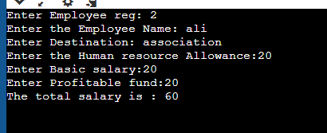

Task 2: Implement the above problem with protected inheritance.

|  |
| --- |
| #include <iostream>  using namespace std;  // Create a class Employee with the following attributes and member functions:  // • Employee registeration number  // • Employee name  // • Destination  // • Human resource Allowance  // • Basic salary  // • Profitable fund  // • Get function to take input of Registeration number, name and destination.  // Inherit(public) a class Salary from employee . Salary should contain the following  // member functions:  // • Get function to take input of human resource allowance, basic salary and  // profitable fund.  class Employee  {  protected:      string employee_registeration_number;      string employee_name;      string destination;      // func      // we can also use getline but for now use name without spaces      Employee()      {          cout << "Enter Employee reg: ";          cin >> employee_registeration_number;          cout << "Enter the Employee Name: ";          cin >> employee_name;          cout << "Enter Destination: ";          cin >> destination;      }  };  class Salary : protected Employee  {  public:      int human_resource_Allowance;      int basic_salary;      int profitable_fund;      Salary()      {          cout << "Enter the Human resource Allowance:";          cin >> human_resource_Allowance;          cout << "Enter Basic salary:";          cin >> basic_salary;          cout << "Enter Profitable fund:";          cin >> profitable_fund;      }      void getter_salary()      {          cout << "The total salary is : " << human_resource_Allowance + basic_salary + profitable_fund << endl;      }  };  int main()  {      Salary sal;      sal.getter_salary();      return 0;  } |

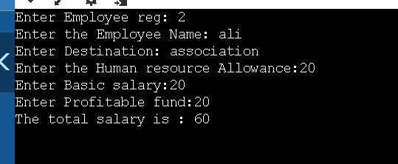

Task 3:

|  |
| --- |
| #include <iostream>  using namespace std;  // Create a class Employee with the following attributes and member functions:  // • Employee registeration number  // • Employee name  // • Destination  // • Human resource Allowance  // • Basic salary  // • Profitable fund  // • Get function to take input of Registeration number, name and destination.  // Inherit(public) a class Salary from employee . Salary should contain the following  // member functions:  // • Get function to take input of human resource allowance, basic salary and  // profitable fund.  class Employee{  private:  string employee_registeration_number;  string employee_name;  string destination;  int human_resource_Allowance;  int basic_salary;  int profitable_fund;  public:  // func  // we can also use getline but for now use name without spaces  Employee()  {  cout << "Enter Employee reg: ";  cin>> employee_registeration_number;  cout << "Enter the Employee Name: ";  cin >> employee_name;  cout << "Enter Destination: ";  cin >> destination;  }      };  class Salary: protected Employee  {  public:  Salary()  {  cout << "Enter the Human resource Allowance:";  cin>> human_resource_Allowance;  cout << "Enter Basic salary:";  cin>>basic_salary;  cout << "Enter Profitable fund:";  cin>>profitable_fund;  }  void getter_salary()  {  cout << "The total salary is : "<< human_resource_Allowance + basic_salary + profitable_fund<<endl;  }  };  int main()  {  Salary sal;  sal.getter_salary();  return 0;  } |

Output:

Not accessible.